User Guide

**By Zeeshan Abbasi**

**Revision 1.1**

**CMSC 495-7981**

|  |  |  |  |
| --- | --- | --- | --- |
| **Revision Number** | **Date** | **Description** | **Name(s)** |
| 1.0 | 5/5/20 | Document created, added hardware and software requirements, added installation instructions, | Zeeshan Abbasi |
| 1.1 | 5/5/20 | Screenshots created and added to each section. | Zeeshan Abbasi |

**Requirements:**

Hardware and software requirements to run OLIP:

* Browser such as Google chrome is required
* Apache
* PHP
* MySQL
* Apache, PHP and MySQL can be installed together with Xampp for windows.
* Visual studio
* CPU: 1 GHz processor
* RAM: 2GB RAM (64-bit)
* Storage must be high so at least 20GB storage
* Graphics: DirectX 9 graphics device with WDDM 1.0 or higher driver

**Installation:** How to install your software

* For installation of software you have to download the code from Github (<https://github.com/Zeeshanabbasi88/CMSC495--Online-Life-Insurance-Portal>)
* Install Visual Studio
* Then open file in visual studio and add specific file in it ,as shown below:

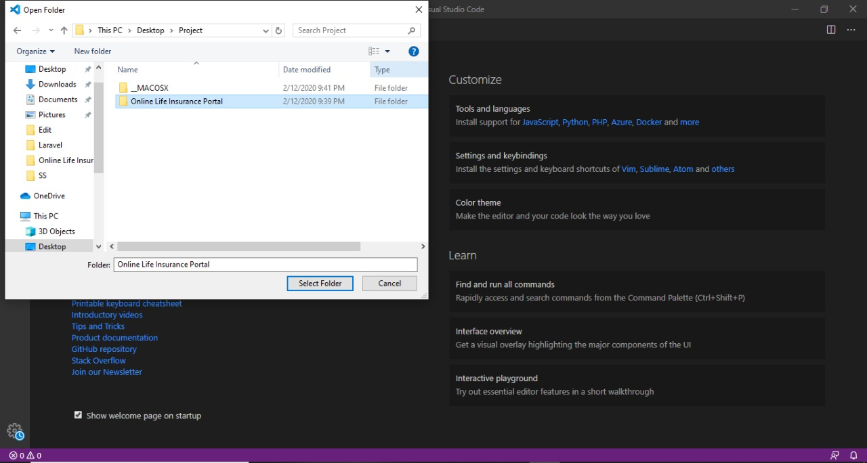

* And run the code

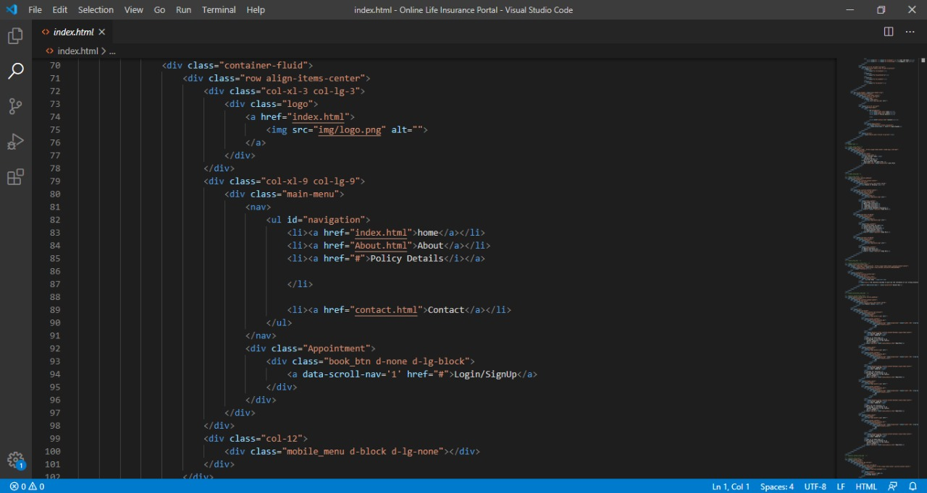

* By running the code you will open different pages of website one by one. As a lot of work is still under process. This is just demo of project.
* You will see the page open up in your specific browser and showing the main menu page, as shown below:



**Operations: How to use your software**

To use software you have to open the website on which main page will appear as shown below in figure 1.



**Figure 1:** Main Page of Online Life Insurance Portal

Figure 1 displays the main page on which you can see the header which includes the following buttons:

* Home
* About
* Policy details
* Contact
* Login/signup

By using home button you can open a page which includes the detail about this specific website. About tells us details and goals of this OLIP website as shown in figure 2. Policy details includes all the policies and its details from which you can get information about different policies. But to take advantage of such policy you have to sign up or login into website for further processing and for which signup and login buttons are included on top.

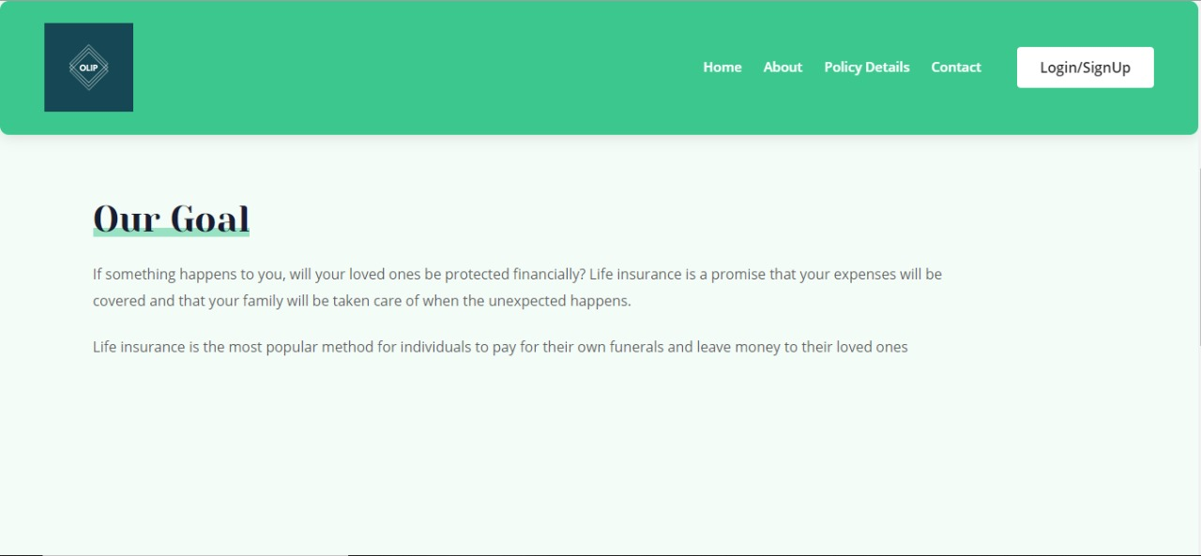

**Figure 2:** About-goal of OLIP

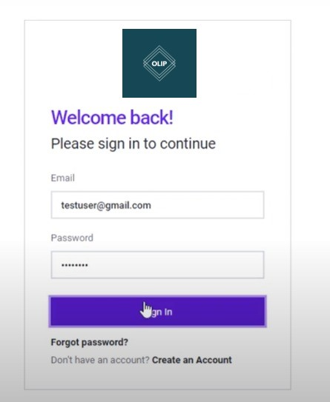

**Figure 3**: Login page of OLIP

Figure 3 shows the login page which include username and password. User have to enter username and password to login into account of OLIP. If a person is new to this website he/she can sign up on signup page as shown in figure 4.

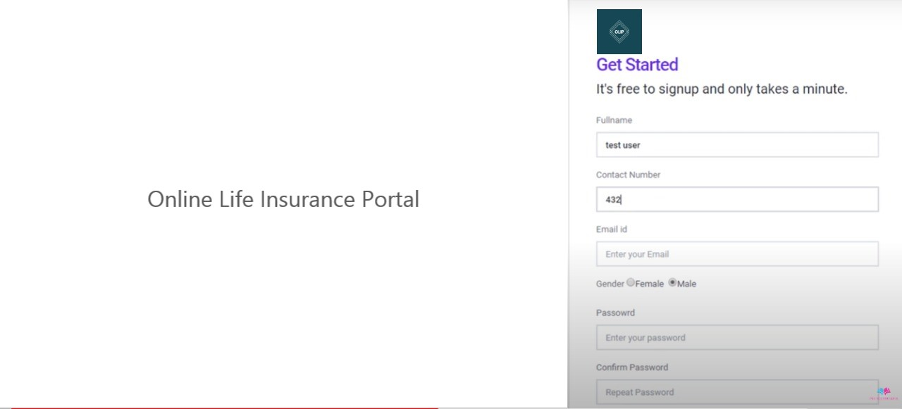

Figure 4: Displays the sign up page

By using this page user can get register into OLIP website and can login into account. After getting logged in user can visit profile as shown in figure 5

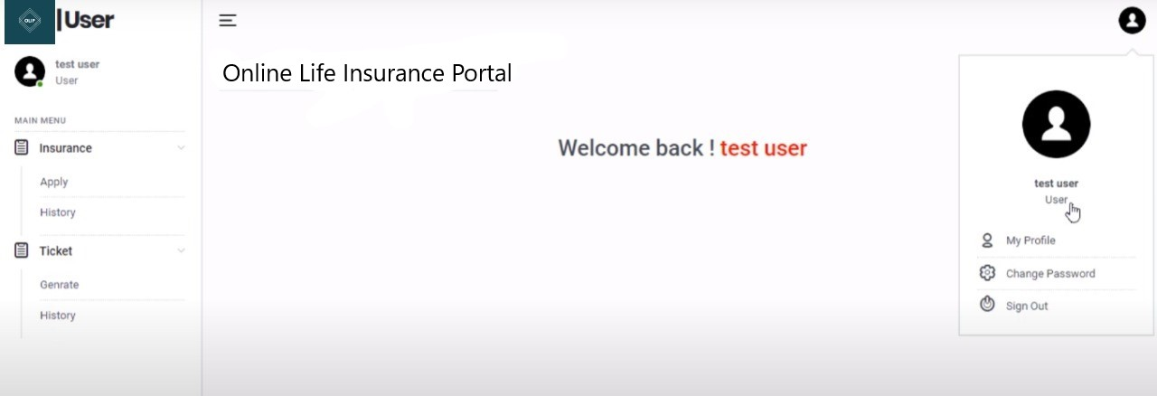

Figure 5: User Profile interface

Figure 5 displays the user interface in which on right side a user can manage his profile by viewing/editing profile, user can change password and user can sign out from account. On left side a user can apply for any policy and can view history from account. A user can send ticket as well to admin if something wrong happened or user need any guideline. Admin will handle all the queries.

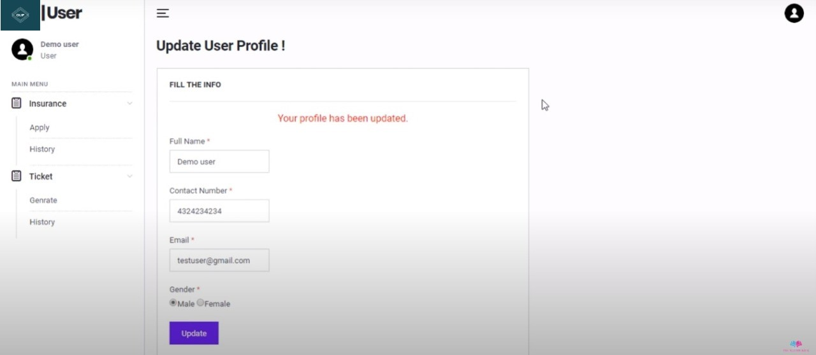

Figure 6: Displays the profile updating

Figure 6 shows that user can update his profile by adding few required information and after adding those information a message will be displayed by database “Your profile has been updated” as shown in figure 6.

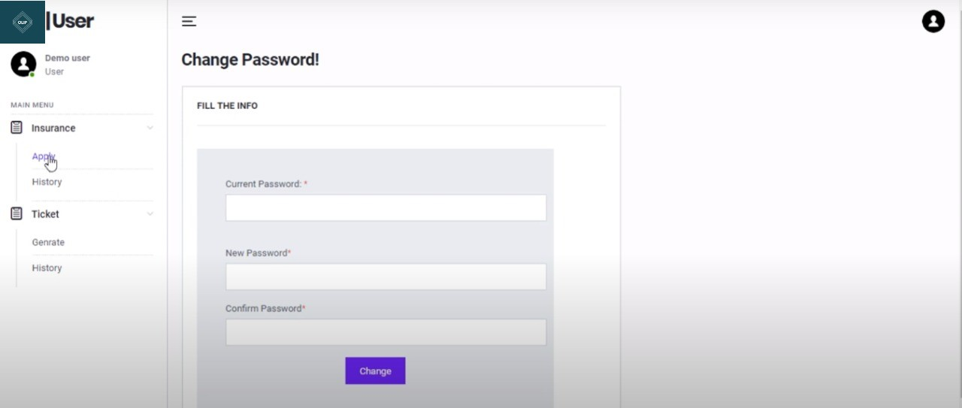

Figure 7: Change the password

Figure 7 shows that password can be managed by using change the password from user profile. It can be changed, updated as user wanted.

These are the few steps a user can perform on OLIP website yet, a lot of implementation is still in process.